EXPT NO:2 | Implementation of data visualization techniques
DATE: 06.01.2026 | Implementation of data visualization techniques

PRE-LAB QUESTIONS (PROVIDE BRIEF ANSWERS TO THE FOLLOWING QUESTIONS)
- Why is exploratory data analysis critical before model building?
- It helps understand the structure, patterns, and quality of data.
- Detects missing values, noise, and inconsistencies early.
- Reveals relationships between variables that guide feature selection.
- Prevents building models on wrong assumptions or poor data.
- How do distributions influence algorithm selection in ML?
  - Some algorithms assume normal or symmetric distributions (e.g., Linear Regression).
  - Skewed data may require transformations or robust models.
  - Algorithms like tree-based models work well regardless of distribution.
  - Distribution shape affects loss functions, distance metrics, and performance.
- What insights can outliers provide in business data?
- They may indicate fraud, errors, or rare but important events.
- Highlight high-value customers or extreme demand patterns.
- Reveal process failures or exceptional business conditions.
- Help improve risk management and decision-making.
- Why are visual summaries preferred over raw tables?
- Humans understand patterns and trends faster visually.
- Visuals quickly expose relationships, outliers, and distributions.
- Tables are hard to interpret for large datasets.
- Visual summaries support faster and clearer insights.
- How does visualization improve business intelligence?
  - Converts raw data into actionable insights.
  - Helps identify trends, opportunities, and risks quickly.
  - Enables data-driven decision making for managers.
  - Improves communication of insights across teams.
IN-LAB EXERCISE:
OBJECTIVE:
To explore data distribution and variability using advanced visualization techniques.
SCENARIO:
A startup analyzes e-commerce transaction data to understand customer spending behavior and detect abnormal purchase patterns.

IN-LAB TASKS (Using R Language)
- Plot histogram of transaction amounts
- Use boxplot to detect outliers
- Create heatmap of monthly sales intensity
(CODE: CONATAINS STUDENT ROLL NOS
SCREENSHOT OF CODE
SCREENSHOT OF OUTPUT)
CODE:
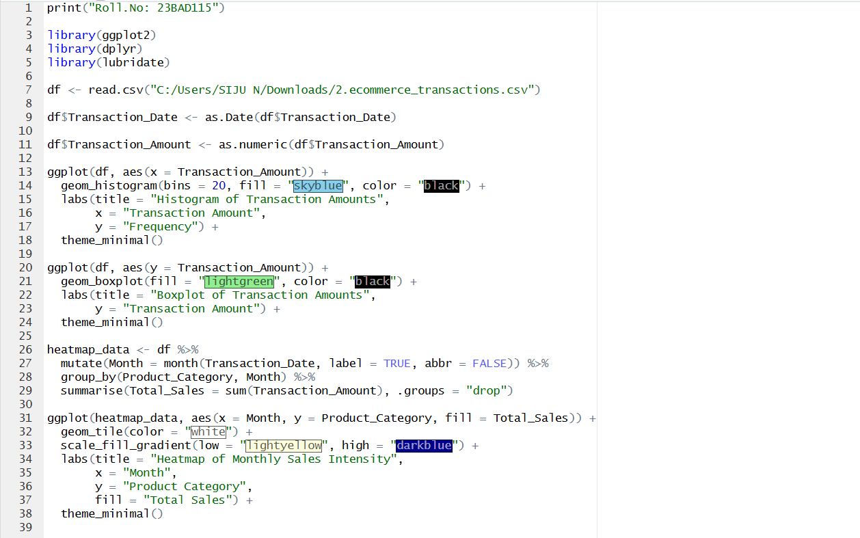

OUTPUT:

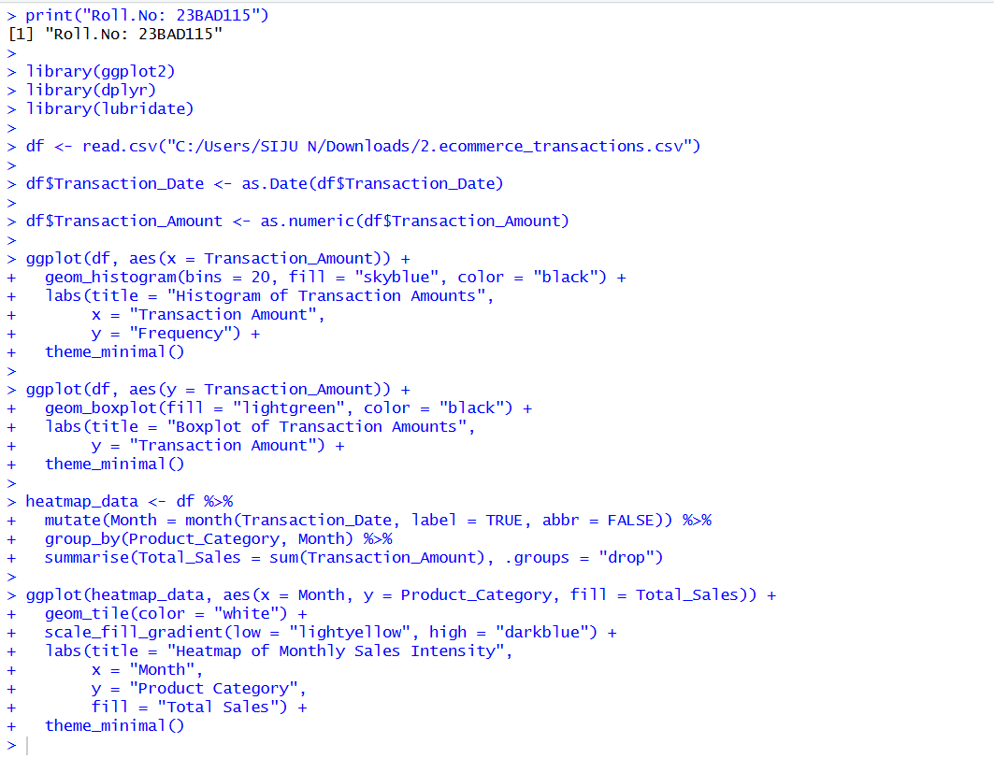

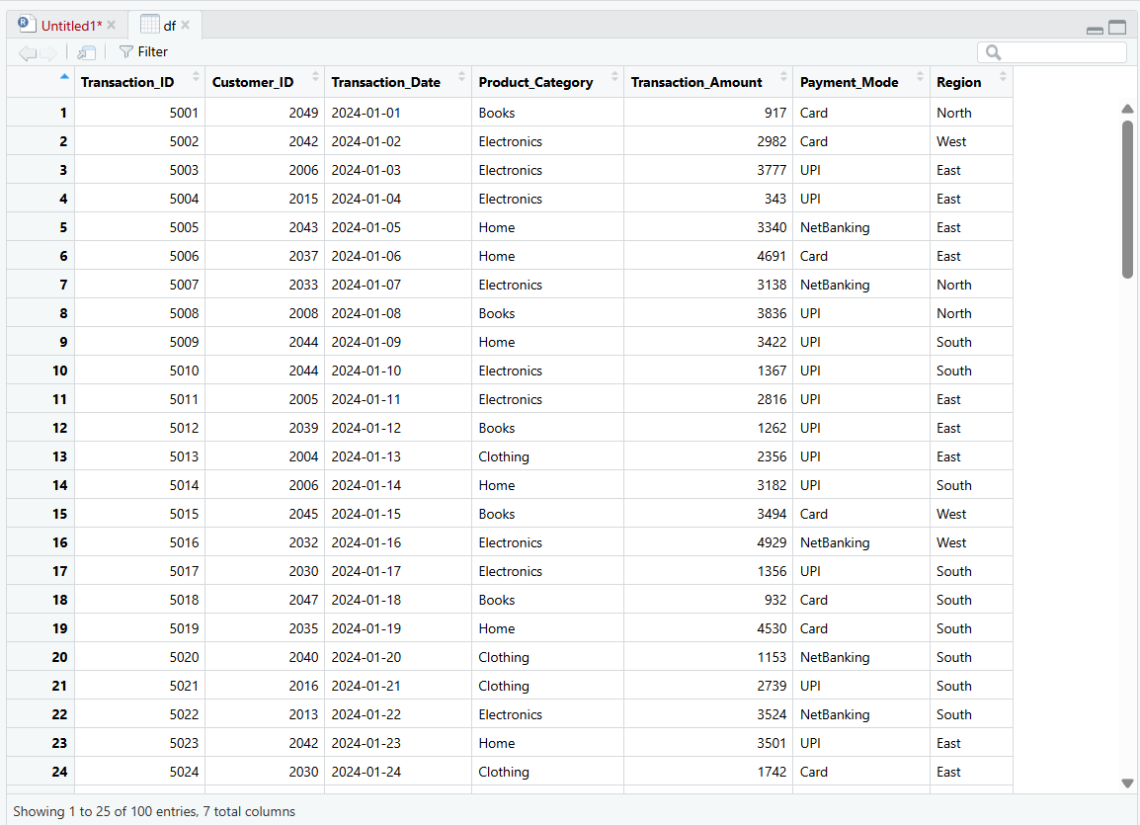

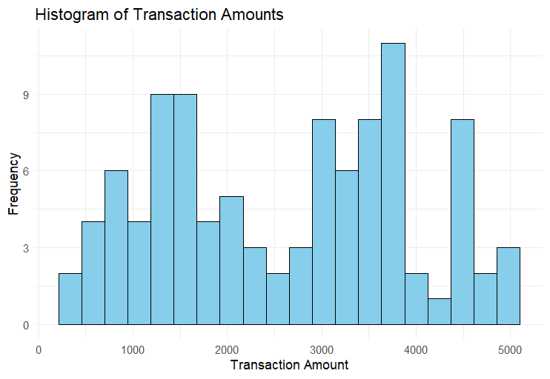

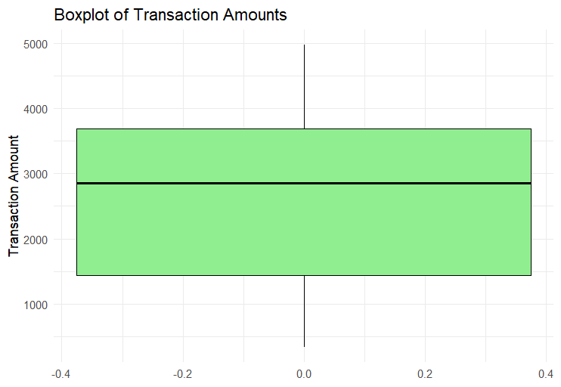

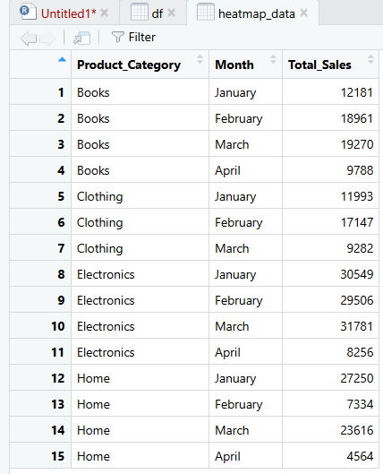

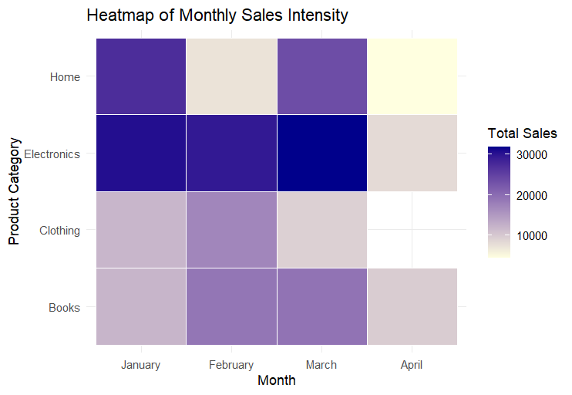
POST-LAB QUESTIONS (PROVIDE BRIEF ANSWERS TO THE FOLLOWING QUESTIONS)
- What does right-skewed distribution indicate about customer behavior?
- It indicates that most customers have lower or average values, while a small number of customers show very high values.
- This often represents heavy spenders or frequent users who significantly impact revenue.
- How can detected outliers impact business decisions?
- Outliers may represent fraud, data errors, or exceptional business cases.
- Identifying them helps businesses take corrective actions, reduce risk, and exploit high-value opportunities.
- Which visualization best supports anomaly detection?
- Box plots are most effective as they clearly display median, spread, and extreme values.
- They make it easy to identify anomalies and unusual data points.
- How does EDA improve AI model accuracy?
- EDA helps in understanding data patterns, handling missing values, and removing noise.
- This leads to better feature selection and more accurate model predictions.
- How can visualization guide feature engineering?
- Visualization reveals relationships, trends, and correlations between variables.
- These insights help in creating new meaningful features that improve model performance.

ASSESSMENT
Description | Max Marks | Marks Awarded
Pre Lab Exercise | 5
In Lab Exercise | 10
Post Lab Exercise | 5
Viva | 10
Total | 30
Faculty Signature

